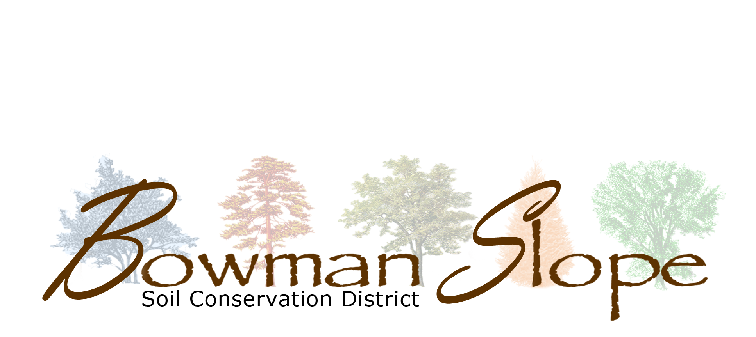
John Deere 1590 Drill Rental Agreement

On behalf of myself and my insurers, executors, administrators, heirs, successors and assigns, I herby:
- Agree to pay the Bowman-Slope Soil Conservation District:
  - $500 Up-Front fee, due before the drill is taken, includes:
  - $200 Deposit, which can be applied to bill if no damage is done to drill, $300 Minimum Use Charge
  - $10.00 per acre, with a minimum of $300 per day charge. (SCD Board may waive per day charge at their discretion, case-by-case)
- Agree to provide the SCD with the drill acre meter reading before and after I use the drill. If the meter reading is not provided to the SCD, within 5 days of use, it is a $250 fine.
- Agree to operate the drill according to the operators’ manual instructions.
  - 1590 JD Drill: review the FIELD QUICK CHECK (This reference page is intended as a guide to pre-field attachments and settings)
  - 1590 JD Drill: Am aware that the large drill box is equipped with a half-speed attachment and I will need to follow the seed index settings for pounds of seed per acre, on 7.5 inch row spacing, in the operator manual or drill box chart.
  - Before roading and/or moving the drill, make sure drive wheel is disengaged, jack is up and/or in vehicle, hoses are hung up on hooks.
- Agree to grease and do a daily maintenance of the drill. I will provide the necessary hydraulic adapter (if needed).
- Agree to pick-up the drill at the designated location and tow the drill with a tractor or nothing less than a heavy ¾ ton pick-up at a speed not to exceed more than 25 miles per hour.
- Will be responsible for any damages to the drill while in my possession. If the drill requires any repairs, I will contact the Bowman-Slope Soil Conservation District regarding repairs.
- Agree not to turn too sharply in the field with disks down. This will help prevent damages to the disks.
- Agree to assume the full risk of any injuries, death, damages or other loss regardless of severity which I may sustain as result of agricultural services provided by Bowman-Slope Soil Conservation District.
- Waive, release, and discharge Bowman-Slope Soil Conservation District, its agencies, officers, employees, and volunteers from any and all liability for death, disability, personal injury, loss of damage to property, or actions of any kind, including unforeseen agricultural production results of any nature which may hereafter accrue as a result of agricultural service provided by Bowman-Slope Soil Conservation District agricultural services.
- Indemnify, save, and hold harmless Bowman-Slope Soil Conservation District, its agencies, officers, employees, and volunteers from any and all claims of any nature, including, cost, expenses, and attorneys’ fees which may in any manner result from or arise out of Bowman-Slope Conservation District agricultural services.
- I will completely clean out the seed box and fertilizer box when I am finished using the drill.
- Agree to certify my actual acreage use with the Bowman-Slope Soil Conservation District staff, for proper billing, when I am done seeding.
WAIVER, RELEASE, AND INDEMNIFICATION
Read this form carefully and be aware that you, by signing, will be waiving and releasing all claims for injury, damage, or unforeseen agricultural productions results you may sustain from the agricultural services provided by Bowman-Slope Soil Conservation District. I am fully aware of and understand the dangers inherent in the agricultural services that are being provided and that they may cause property damage, physical injury, or death to myself or others or may not provide the expected agricultural production results. This waiver, release, and indemnification shall be construed broadly to provide a waiver, release and indemnity to the maximum extent permissible under applicable law. Any modification of this waiver must have written approval by Bowman-Slope Soil Conservation District prior to provision of agricultural services.

I HAVE READ AND FULLY UNDERSTAND THE ABOVE AGREEMENT SPECIFYING MY WAIVER, RELEASE, AND INDEMNIFICATION OF ALL CLAIMS.

Print Name: _______________________________ Acreage Estimate: _______________

Phone: ___________________________________ Meter Reading Before: ________After: __________

Signature: __________________________________ Date: ___________ Deposit Paid_________

